"Smart Industrial Robot Control Trends, Challenges and Opportunities within Manufacturing":

1. Current Trends in Smart Industrial Robot Control:

The paper then focuses on the different control methods used for smart industrial robots, categorized by their underlying learning approaches:

Computer Vision-Based Control: This approach utilizes computer vision and deep learning algorithms to detect objects, estimate their position and orientation, and plan grasping motions. The paper highlights the potential of this method for tasks like bin-picking and complex object manipulation.

Deep Reinforcement Learning-Based Control: This approach focuses on training robots to learn optimal actions through trial and error within an environment. The paper discusses how this approach can be used for grasping in complex scenarios, such as cluttered environments, and for tasks that require pushing objects before grasping them.

Imitation Learning-Based Control: This method involves training robots by learning from demonstrations provided by humans. The paper explores different ways to acquire these demonstrations, such as teleoperation, kinesthetic teaching, and video demonstrations, and how they can be used to teach robots complex tasks.

"Research and Application of Industrial Robot Manipulators in Vehicle and Automotive Engineering, a Survey", explores the growing use of industrial robots in the automotive industry and their different applications, emphasizing the benefits and challenges of integrating robots.

1. Key Industrial Robotics Applications:

The paper examines the role of robot manipulators in specific automotive manufacturing operations:

Welding: The paper describes the use of robots in welding, emphasizing their ability to improve speed, accuracy, and quality compared to manual welding. It delves into the use of hybrid algorithms (ant colony and genetic algorithms) and speech recognition to optimize welding processes.

Grinding and Polishing: The paper discusses the use of robots in finishing and polishing, highlighting the advantages in accuracy, efficiency, and safety compared to human workers. It mentions various types of grinding, including belt grinding, and the importance of considering temperature and material properties during grinding.

Cutting: The paper explores the use of robots with CNC machines for cutting complex shapes in automotive manufacturing. It addresses the challenges of low stiffness in cutting robots and discusses techniques for optimizing tool positioning and cutting streams.

Assembly: The paper focuses on the use of robots for assembly tasks, highlighting the benefits of using robot manipulators to assemble complex structures, often involving heavy parts or requiring precise movements. It also touches on the challenges of working in collaborative environments with humans.

Painting: The paper explores the use of robots in painting applications, discussing the use of experimental algorithms and offline trajectory optimization for achieving accurate and consistent paint application.

3. Optimization and Robot Design:

The paper emphasizes the importance of optimization techniques for robot trajectory planning and robot design:

Trajectory Optimization: It discusses the use of optimization algorithms (e.g., A star, ant colony, genetic algorithms, neural networks) to determine the most efficient path for robots to follow in different applications.

Robot Design Optimization: It explores the use of optimization techniques (e.g., topology optimization, non-linear Levenberg-Marquardt) to design robots with optimal link lengths and structures for specific tasks, minimizing errors and improving performance.

The paper "Advanced Applications of Industrial Robotics: New Trends and Possibilities" offers a comprehensive overview of industrial robotics, going beyond the traditional applications in manufacturing. It explores new areas where robots are finding their place and analyzes the key challenges and opportunities associated with these applications.

1. Recent Advancements in Robotics Applications:

The paper then delves into recent achievements in robotics across various industries, examining applications beyond traditional manufacturing:

Human-Machine Interaction: This section focuses on the development of more intuitive and collaborative interfaces between humans and robots. It highlights research on haptics, AI-aided anticipation, and understanding human emotions.

Object Recognition: This section explores the use of computer vision and deep learning for object recognition in various tasks, such as sorting, packaging, and assembly. It discusses the challenges and advancements in dealing with complex objects, cluttered environments, and recognizing objects in real-time.

Path Planning and Optimisation: This section examines the use of algorithms to generate efficient robot paths, avoiding obstacles and maximizing efficiency. It highlights the challenges of real-time path planning and the increasing use of sensor data to improve path accuracy.

Medical Applications: The paper explores the use of robots in surgery, rehabilitation, and dentistry, highlighting the challenges of data acquisition, transfer learning, and incorporating human-like touch and perception.

Food Industry: The paper reviews the use of robots in food processing, packaging, and delivery, noting the growing adoption of robots in restaurants and the need for solutions that can handle fragile objects and meet food safety standards.

Agricultural Applications: This section examines the use of robots in farming, highlighting their potential for tasks such as weeding, harvesting, and crop monitoring. It discusses the challenges of working in unpredictable outdoor environments and the growing use of autonomous vehicles and drones.

Civil Engineering: The paper discusses the challenges and opportunities of using robots in construction, highlighting their potential for automating repetitive and dangerous tasks, as well as their use in 3D printing and modular construction.

This paper, "Applications of Collaborative Industrial Robots in Building Construction," explores the potential of collaborative robots (cobots) to revolutionize construction practices. It emphasizes the safety, flexibility, and affordability of cobots and investigates their potential applications in building construction.

1. Examples of Collaborative Robots:

The paper reviews several popular models of collaborative robots:

Baxter: A two-armed robot developed by Rethink Robotics, known for its safety features and user-friendliness.

YuMi: A two-armed robot from ABB, designed specifically for small-part assembly and safe collaboration with humans.

UR Series: A series of single-armed robots from Universal Robots, known for their ease of use and ability to be integrated into existing workspaces.

2. Applications of Collaborative Robots in Construction:

The paper explores the potential applications of collaborative robots in construction:

Material Handling: Cobots could assist workers in moving and handling materials, especially for repetitive or strenuous tasks.

Material Shaping: Cobots could perform shaping tasks, such as cutting or grinding, in a safe and collaborative manner.

Material Joining: Cobots could be used for tasks like joining pipe fittings, reducing the need for human workers to perform heavy lifting and potentially dangerous work.

This paper, “Design of a robotic manipulator for handling products of automotive industry" presents a comprehensive design of a robotic manipulator specifically tailored for the automotive industry. The focus is on handling various products, including both circular and angular shapes, on an automated production line.

Here's a summary of its key applications:

Automated Production Line Integration: The robotic manipulator is designed to seamlessly integrate into existing automated production lines, streamlining the handling of automotive components. This can dramatically increase production efficiency and accuracy, reducing manual labor and potential human error.

Versatile Handling of Automotive Products: The manipulator's ability to handle both circular and angular objects makes it highly adaptable for a wide range of automotive components, such as engine parts, body panels, and interior components. This versatility expands its applicability within the automotive manufacturing process.

Improved Efficiency and Safety: By automating handling tasks, the manipulator contributes to increased production efficiency and a safer working environment. It eliminates the need for workers to perform potentially hazardous or repetitive tasks, reducing the risk of injuries and worker fatigue.

Enhanced Accuracy and Precision: The robust design and meticulous force calculations ensure precise and reliable handling, minimizing errors and improving product quality. This is crucial in the automotive industry, where high precision is essential for achieving proper assembly and function.

Cost Reduction: By minimizing manual labor and optimizing production flow, the robotic manipulator can significantly reduce labor costs and improve overall manufacturing efficiency.

Overall, the paper highlights a practical solution to a common challenge faced by the automotive industry - efficient and reliable handling of various components within a production line. This application has the potential to significantly impact the industry's competitiveness and efficiency, leading to improved product quality and reduced production costs.

**Milestone 2 Deliverables:**

* **Coordinate Frame Assignment:**
* 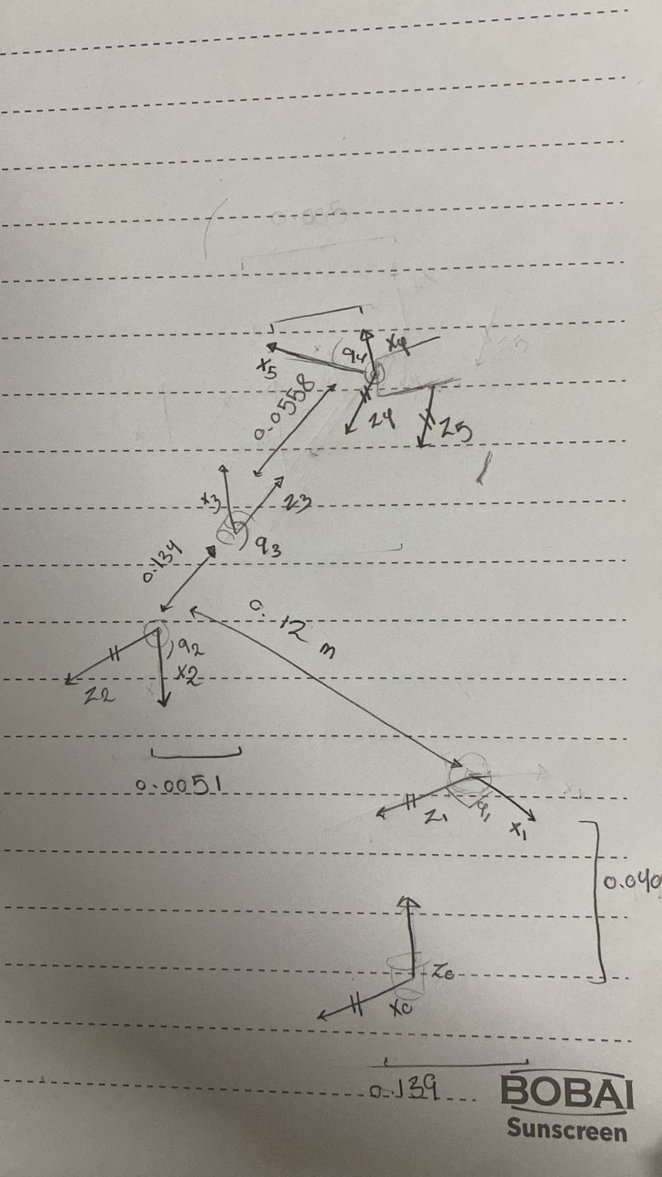
* **DH-Convention Table:**

|  |  |  |  |  |
| --- | --- | --- | --- | --- |
|  | θ | d | a | α |
| 0 🡪 1 | q1 | L1 | 0 | π |
| 1 🡪 2 | q2 | 0 | L2 | 0 |
| 2 🡪 3 | q3 | 0 | L3 | 0 |
| 3 🡪 4 | q5 | 0 | L4 | 0 |

* **DH-Convention Matrix:**

|  |  |  |  |
| --- | --- | --- | --- |
| 6.1232×10-17 | -6.1232×10-17 | -1.0000 | 0.0134 |
| -1.0000 | 1.2246×10-16 | −6.1232×10-17 | 0.1370 |
| 1.2246x10-16 | 1.0000 | -6.1232x10-17 | 0.1503 |
| 0.0000 | 0.0000 | 0.0000 | 1.0000 |

**Milestone 3 Deliverables:**

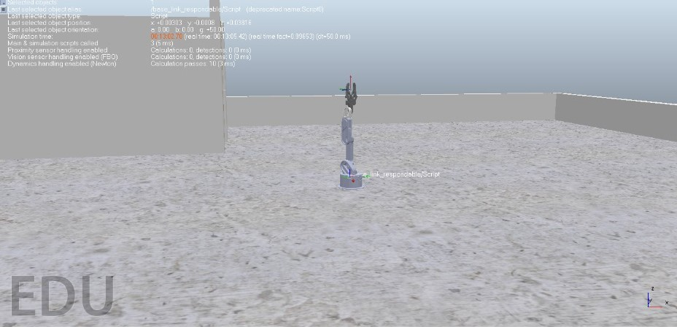

The following are the values used in the Jacobian Matrix by differentiating w.r.t [q1, q2, q3] (each joint was differentiated w.r.t only once)



The initial values that were used were:

* q1 = 130
* q2 = 0
* q3 = 90
* q1 dot = 0.1
* q2 dot = 0.2
* q3 dot = 0.3
  + Forward/Inverse Velocity Kinematics:
    - We used the Trigonometric approach, and were able to calculate the following matrix for the FVK:



* We were then able to calculate the IVK matrix using the following script (also using the Trigonometric approach):

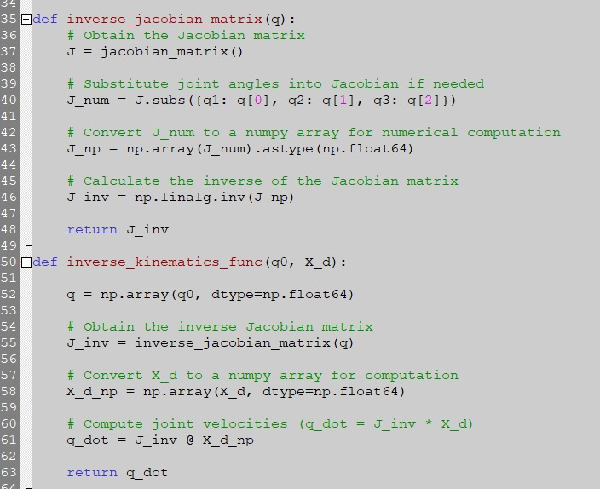

* + **Inverse Position Kinematics:**

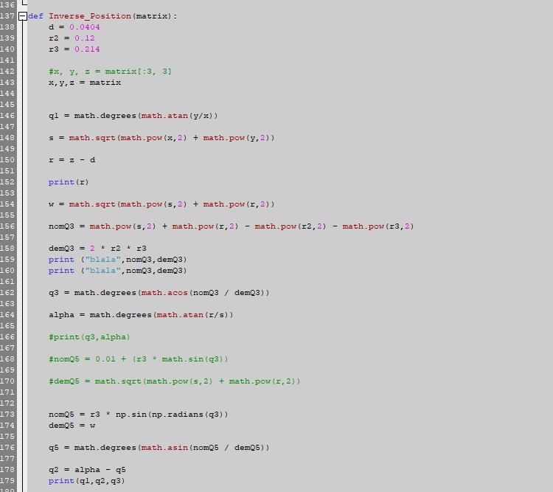

* The above code was used to calculate the Inverse Position Kinematics of the robot, which in our case yielded values of :
* q1 = 88.82 , q2 = -22.96 , q3 = 49.79